[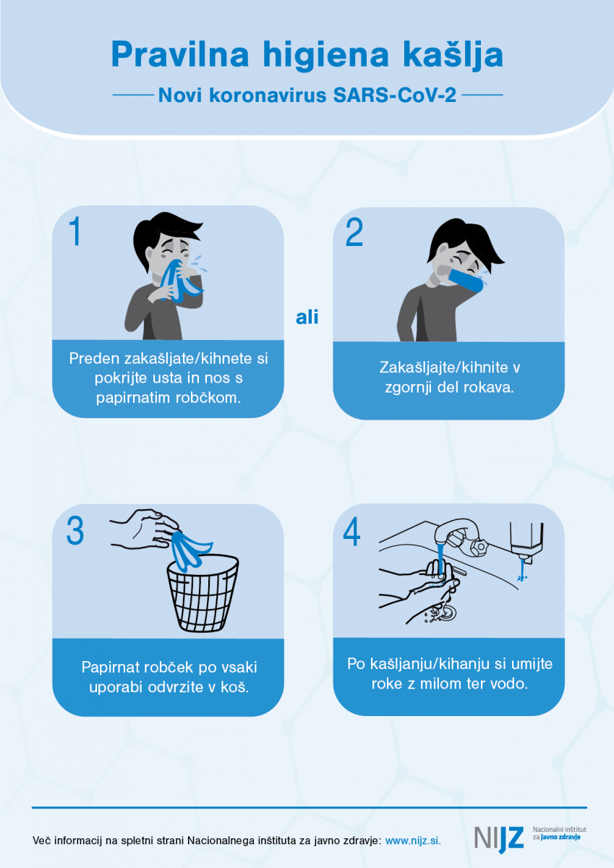](https://www.nijz.si/sites/www.nijz.si/files/uploaded/navodila_higiena-kaslja_0.png)